**2. Use Case Overview**

**Use Case Diagram Level 0: iStore Xpress**

iStore Xpress

Employee

Admin

Use Case Diagram Level 1: iStore Xpress Sub-System (UC100)

iStore Xpress

UC110

Employee

UC120

UC130

UC140

UC150

Use Case Diagram Level 1: iStore Xpress Sub-System (UC100)

UC130

iStore Xpress Sub-System

Employee

UC150

Warehouse staff

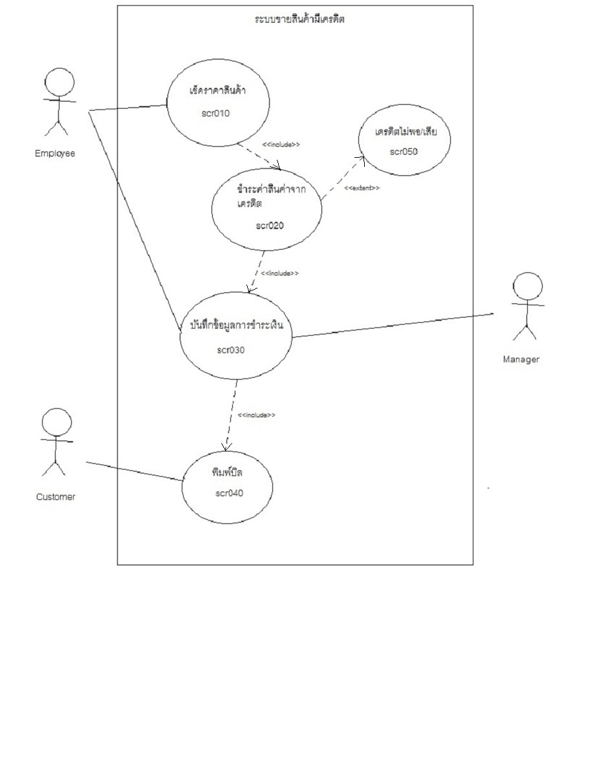Use Case Diagram level 1 **:** ระบบขายสินค้ามีเครดิต Sub-System (UC130)

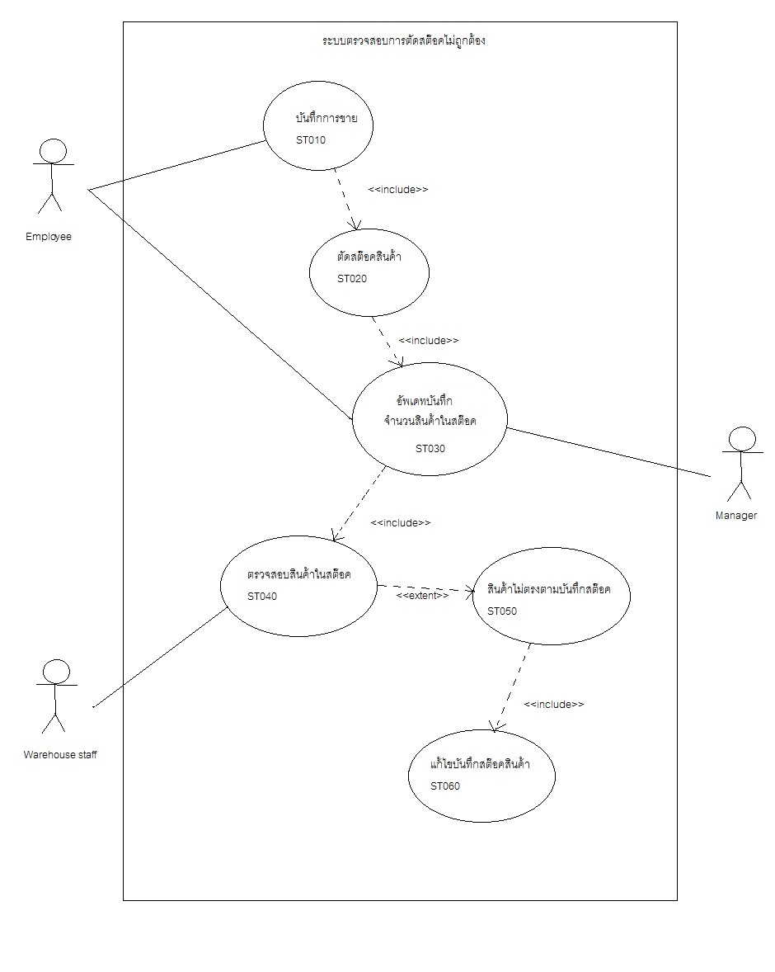Use Case Diagram level 1: ระบบตรวจสอบการตัดสต๊อคไม่ถูกต้อง Sub-System (UC150)